Requirements for Modifying the Ultimus Service Account For Ultimus BPM Suite 7.1

There may be times when company policies limit the password age of service accounts to increase network security. When a change is made to the Ultimus service account, subsequent modifications must be completed in order for Ultimus to continue processing without interruption. The following documentation reviews the requirements and implications within Ultimus for such a configuration change.

Ultimus Configuration Changes

1. Modify the Identity of the Ultimus package in Component Services.

Under Control Panel | Administrative Tools, open Component Services. Select Console Root | Component Services | My Computer | COM+ Application | Ultimus Server.
Right Click the package and select Properties.

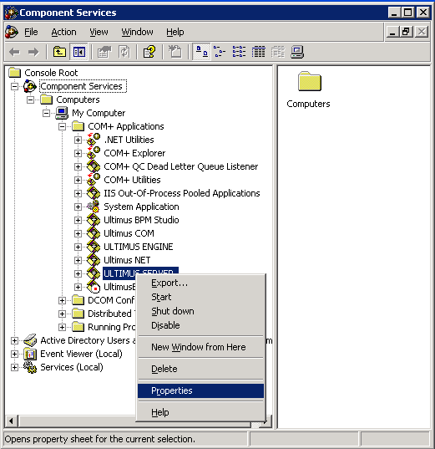

Next, Select the Identity tab, and under the “This User” option enter the new account information.

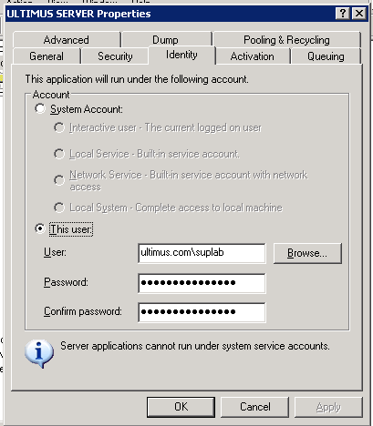

NOTE: Each COM+ package associated with Ultimus will require the same changes. (Ultimus BPM Studio, Ultimus COM, Ultimus Engine, Ultimus NET) and each package will need to be restarted. (Shut Down then Start)

2. Edit the Services Password

Open Control Panel | Administrative Tools | Services. Then select the Ultimus Notification service, right click and select properties. Select the Log On tab and change the account information to reflect the new changes.

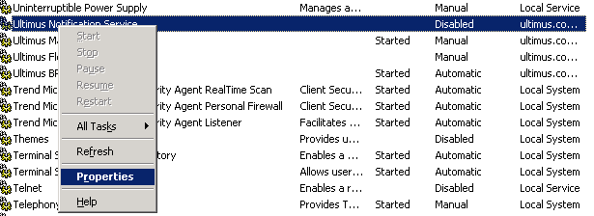

NOTE: Each Service associated with Ultimus will require the same changes. (Ultimus Flostation, Ultimus Management Service, Ultimus BPM) and each service will need to be restarted.

